Sensor Unit L
Product Sheet v2.2



Sensor Performance

Technical Specifications
Feature | Details
Sampling Period | 1, 5, 10, 15, 30, 60 minutes
Unit Life | +10 years
Connectivity | Cellular 4G/NB-IoT w/ 2G compatibility
Operating Conditions | -10°C to +65°C, 10% to 99% RH
Dimensions | 35cm x 25cm x 18cm
Weight | 3.5kg with solar panel
Enclosure | IP34* rated
Powering Options | Solar panel or 5V DC power source
Battery | 3.7V 15.2Ah
Compliance | CE, Engineered to CEN/TS 17660-1 Class 1 & CEN/TS 17660-2 Performance Standards

Packaging Options
Package | Included Components
Lite | PM1, PM2.5, PM10, Ambient Temperature, Relative Humidity and Pressure
Gas-1 | Lite + 1 regular Gas
Gas-2 | Lite + 2 regular Gas
Gas-3 | Lite + 3 regular Gas
Gas-4 | Lite + 4 regular Gas
Gas-Special | Contact us for custom configurations
Customization Options
Regular Gas Sensors: NO, NO2, O3, SO2, CO
Special Gas Sensors: CO2, H2S, VOC, CH4, N2O
External Add-ons: Wind speed/direction, noise monitoring (Class-1 or Class-2), extended solar power package
*Designed with an open sampling architecture for air quality measurement; the enclosure carries an IP34 protection rating.

Parameter | Sensor Type | Accuracy | Range
PM2.5 | Laser scattering | r² > 0.9* | 0-1000 μg/m³ (1μg/m³ resolution)
PM10 | Laser scattering | r² > 0.9* | 0-1000 μg/m³ (1μg/m³ resolution)
NO2 | Electrochemical | r² > 0.82*, LOD: 2 ppb | 0-5000 ppb (1 ppb resolution)
O3 | Electrochemical | r² > 0.82*, LOD: 5 ppb | 0-5000 ppb (1 ppb resolution)
SO2 | Electrochemical | r² > 0.7*, LOD: 5 ppb | 0-5000 ppb (1 ppb resolution)
CO | Electrochemical | r² > 0.8*, LOD: 10 ppb | 0-10 ppm  (1 ppb resolution)
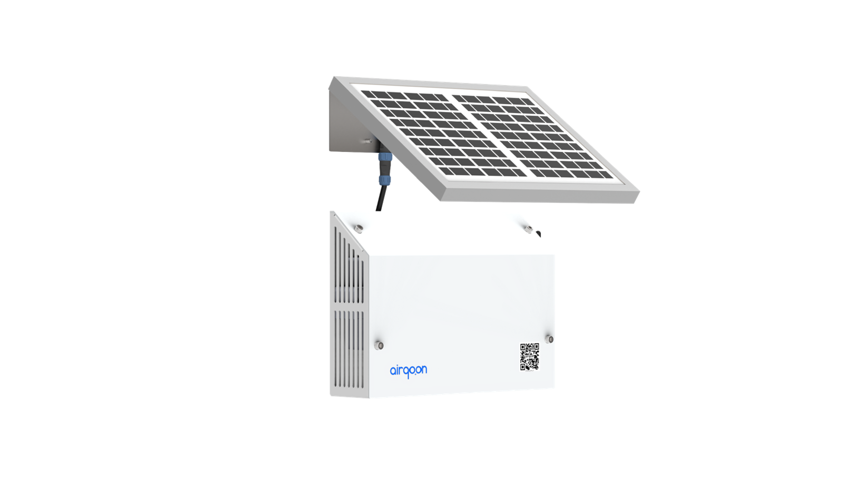
*r²-scores calculated during co-location trials with FEM reference instruments

Key Applications
Municipal Air Quality Networks Identify pollution hotspots and verify mitigation efforts
Industrial Compliance Monitoring Ensure regulatory compliance with accurate, continuous data
Environmental Impact Assessment Measure and validate improvements from green technology investments

Why Airqoon?
Our intelligent calibration process and cloud-based data management system transform raw measurements into actionable environmental intelligence, delivering field-proven performance against reference-grade instruments. Continuous accuracy is maintained through on-site collocation and cloud-based calibration. Designed for rapid deployment, the unit is operational within minutes, no installation expertise required.
7 W Solar Panel

Address: Marmara University Teknopark, Maltepe,
Istanbul – Turkiye
info@airqoon.com
airqoon.com
Core box
IP34
protection
Sensor box
“*”depending on the preferred sampling period and environmental conditions

